**Modeling Collective Anticipation and Response application on Taiwan datasets**

611540005 李宜桓

408410098 蔡嘉祥

408410086 常博愛

**Proposal:**

With the daily page view, observe and make a model to predict the result.

**Modeling Background:**

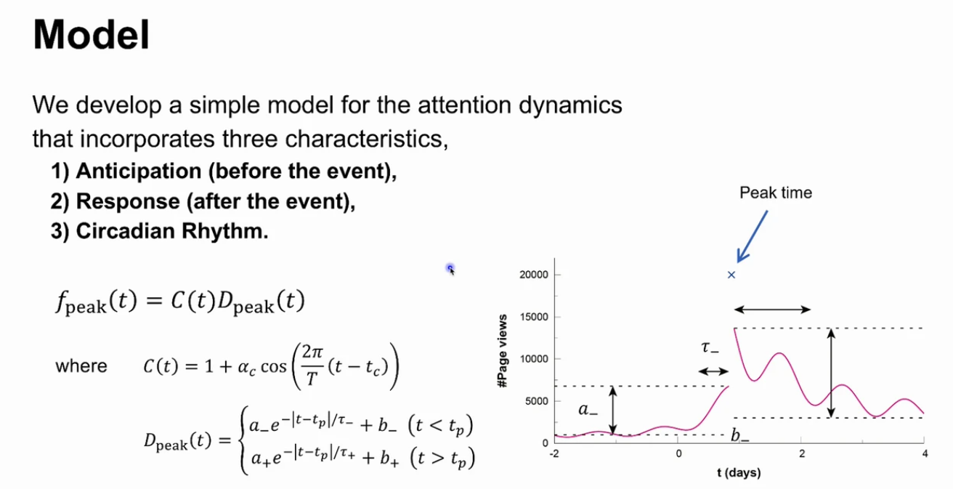

**Data Collection:**

Wikipedia daily page view (from wikipedia REST API)

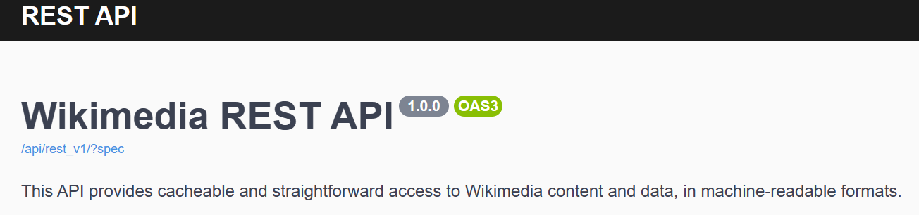

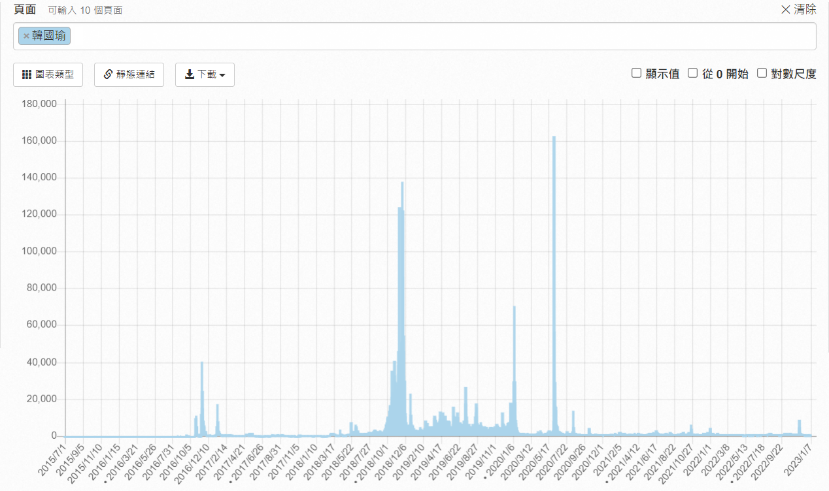

**Discussion:**

1.Weather the model could be applied to the Taiwan’s local datasets?

2.Explore weather could be find more similarities while same kind of planing events facing external impacts through the model?

**Modeling anticipation and response for local dataset (Taiwan Election):**

We have observed the parameters respone to the outcome on local dataset, too.The examples:

1.2022 台北市長選舉

2.2020 總統大選

2022 台北市長選舉

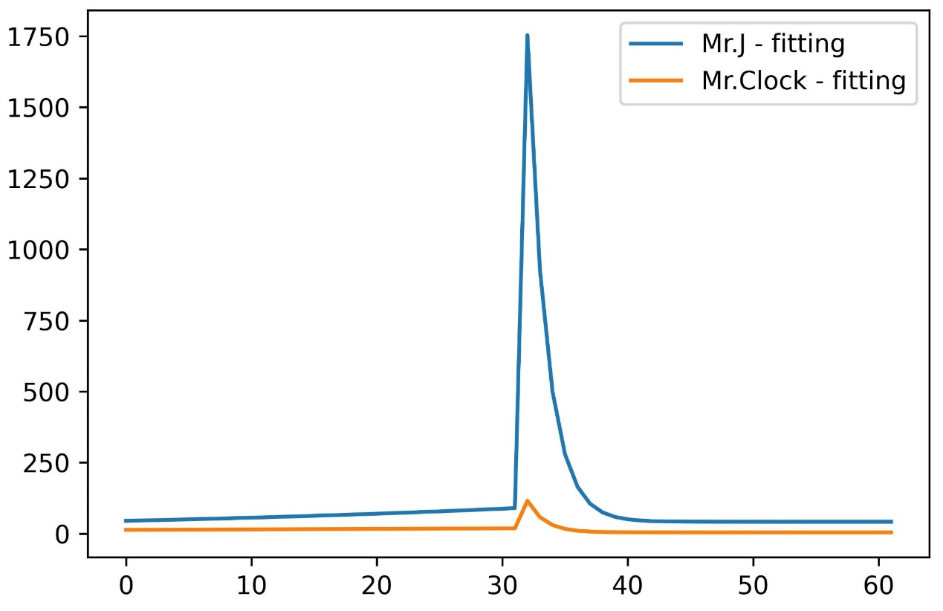

|  |  |  |  |  |  |  |
| --- | --- | --- | --- | --- | --- | --- |
| 候選人頁面 | a- | b- | 𝜏- | a+ | b+ | 𝜏+ |
| 蔣萬安(Mr.J) | 91.588 | 4.87E-08 | 44.891 | 1712.465 | 41.555 | 1.517 |
| 陳時中(Mr.Clock) | 18.7133 | 2.01E-06 | 95.919 | 111.1784 | 4.178 | 1.371 |

2020 總統大選

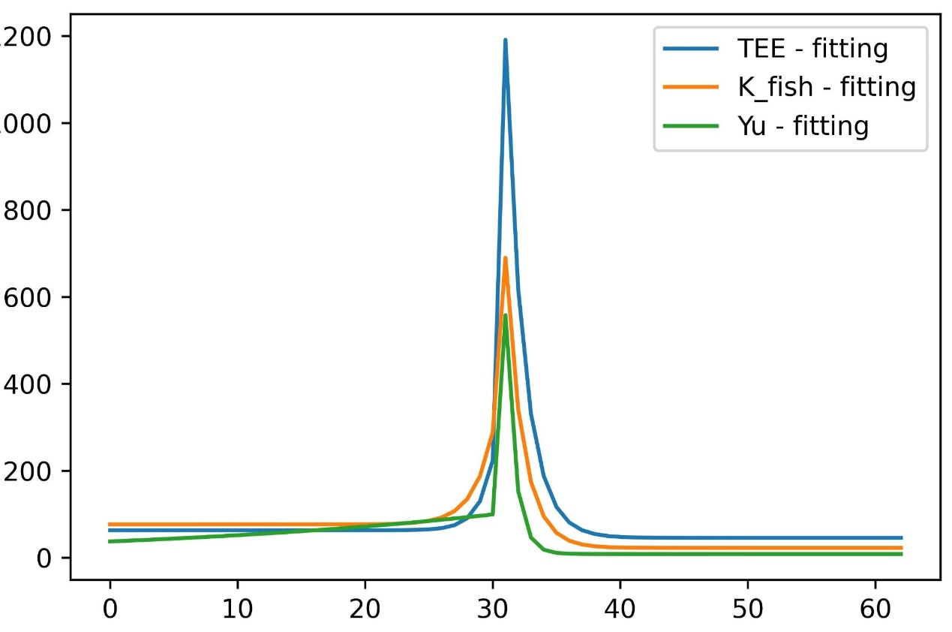

|  |  |  |  |  |  |  |
| --- | --- | --- | --- | --- | --- | --- |
| 候選人頁面 | a- | b- | 𝜏- | a+ | b+ | 𝜏+ |
| 宋楚瑜(Yu) | 102.712 | 1.91E-07 | 30.571 | 549.469 | 8.346 | 0.748 |
| 蔡英文(TEE) | 385.584 | 63.120 | 1.138 | 1145.805 | 45.499 | 1.438 |
| 韓國瑜(K_fish) | 404.110 | 76.491 | 1.547 | 667.221 | 22.422 | 1.351 |

台灣重大選舉事件及政治人物（總統選舉，直轄市選舉）

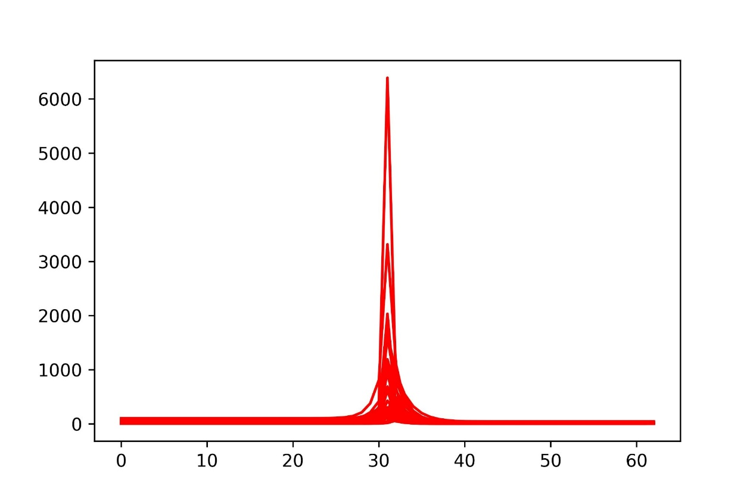

公投事件

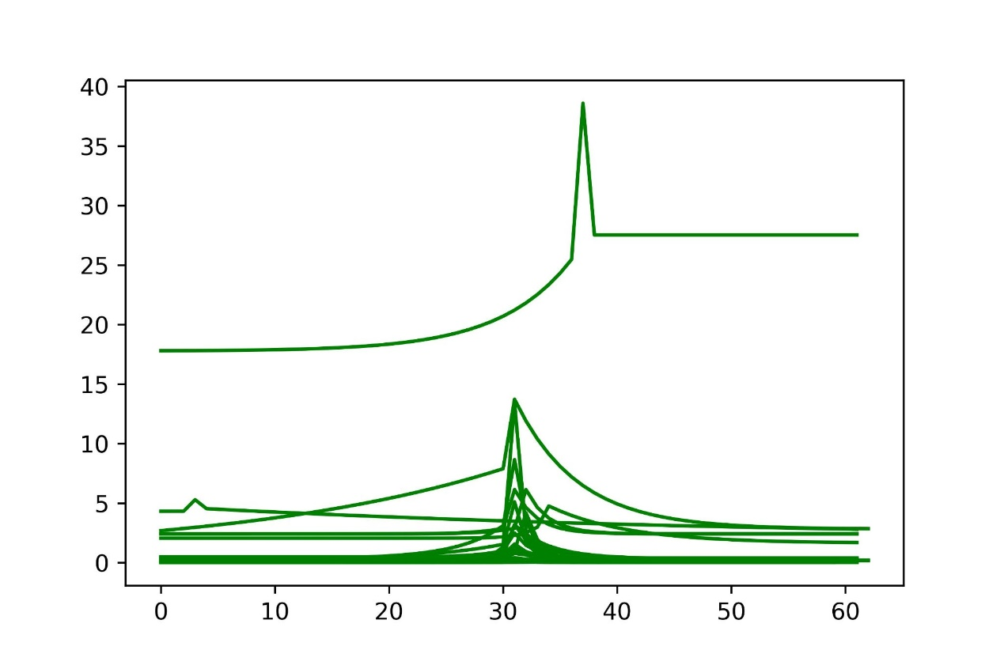

地方性相關政治人物選舉

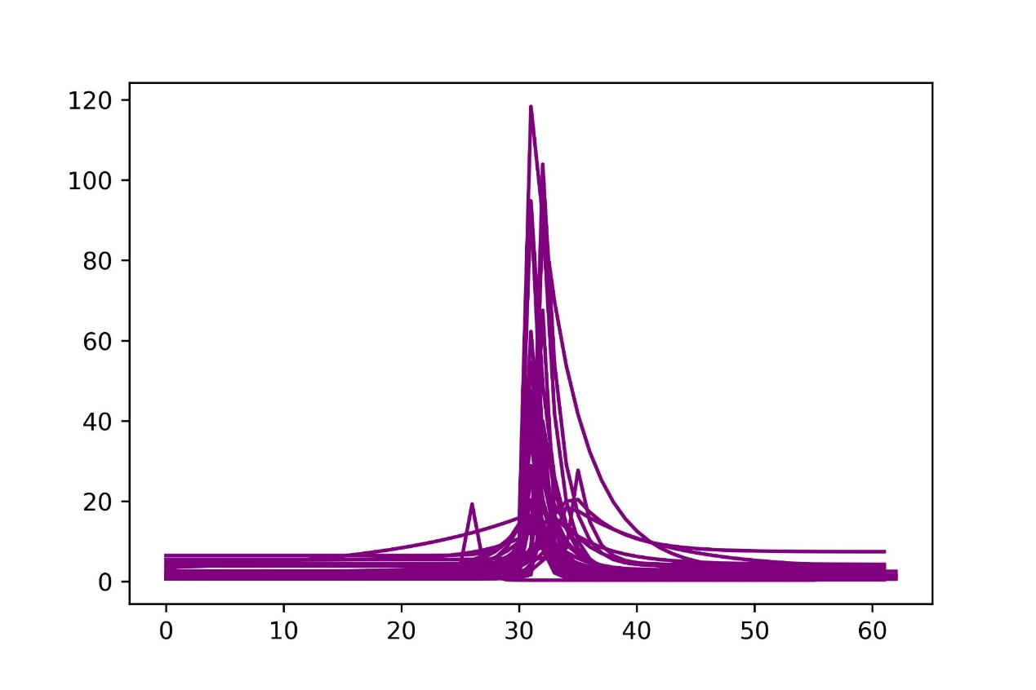

**Conclusion:**

1.The model could be applied to the Taiwan’s local datasets.

2.It could be find more similarities while same kind of planing events facing external impacts through the model.

**Refernce:**

Ryota Kobayashi. Modeling Collective Anticipation and Response on Wikipedia